ASSIGNMENT 1

Tuan Hung Nguyen

COS10004

I. Description of my Assignment 1 circuit

The basic logic of my clock circuit base on JK flip flop counter, this clock has several basic function such as let user adjust the clock, set alarm, and know when it is AM or PM.

II. Design outline

1. General outline

To build up an alarm digital clock, I have to divide the main clock into several sub-circuits ( including the main clock, the alarm clock, compare circuit, switch screen circuit ). When it comes to more specific, each clock has 3 parts: hours part, minutes parts, and seconds part.

The reason for having two 2 clocks are the idea of the alarm base on 2 parallel clocks, if 2 clocks has the same value, the alarm light will on.

1. Specific outline

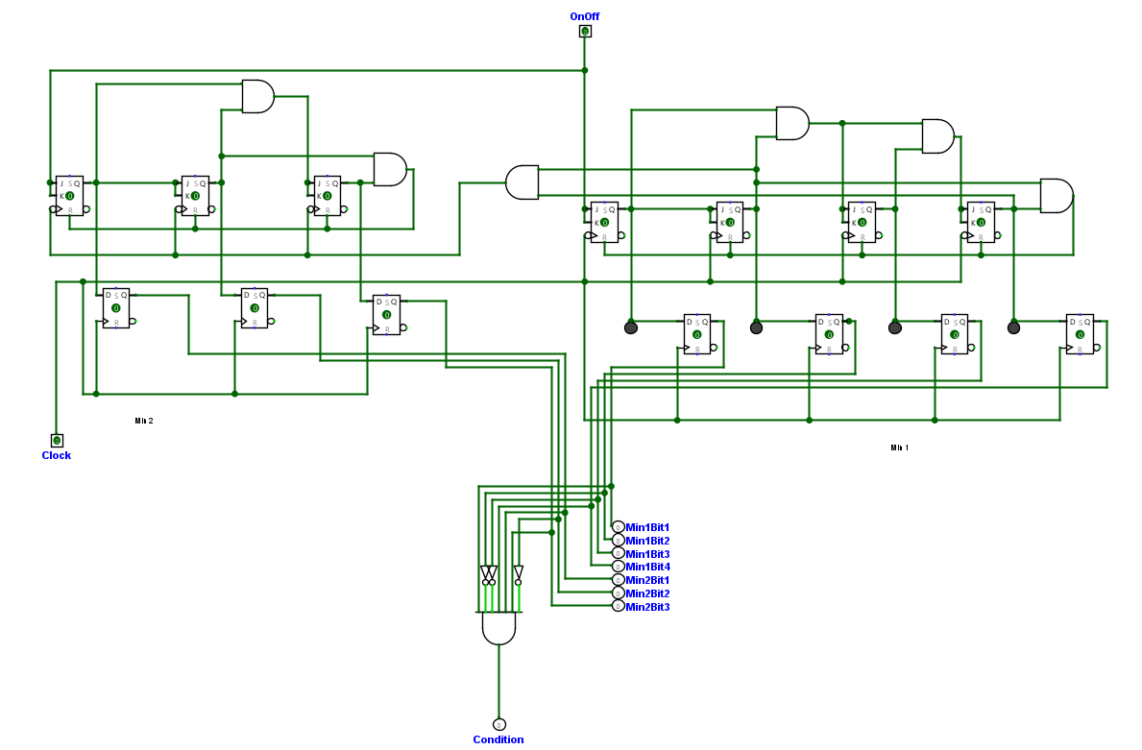

2.2.1.Seconds and Minutes part

The hours, minutes, and seconds part are built on the JK flip flop counter as the lecture tutorial, while seconds and minutes nearly have the same circuit because they both count from 0 to 59, the hours part is more complicated. Firstly, with the minutes and second parts, I create 2 counter, the first ones count from 0 to 9 with 4 JK flip flop and 4 D flip flop for synchronization with the condition to reset is set at 9 ( 1001 ) the second ones count from 0 to 6 and the reset condition is 6 ( 0110 ), then the reset condition ( reach 9 ) of the first counter of minutes and seconds will become the clock pulse of the second counter. 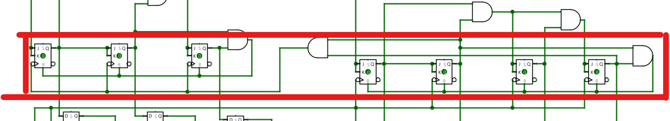

2.2.2. reset condition become clock pulse

Secondly, when it comes to hours, the circuit is nearly the same as minutes, but the difference here is that the reset conditions of the first counter are 9 and 12 and the reset condition of the second counter is 12. Reset condition equal 12 means when both first counters reach 2 and the second ones reach 1. Furthermore, the AM, PM light also attached to the condition reset at 12. That works by using a D flip flop with the toggle output attached to the input and the reset condition goes to the clock pulse, that means each time the clock reaches 12, it will change the status of AM PM light. On the other hand, Alarm is copied from the main clock without any difference. 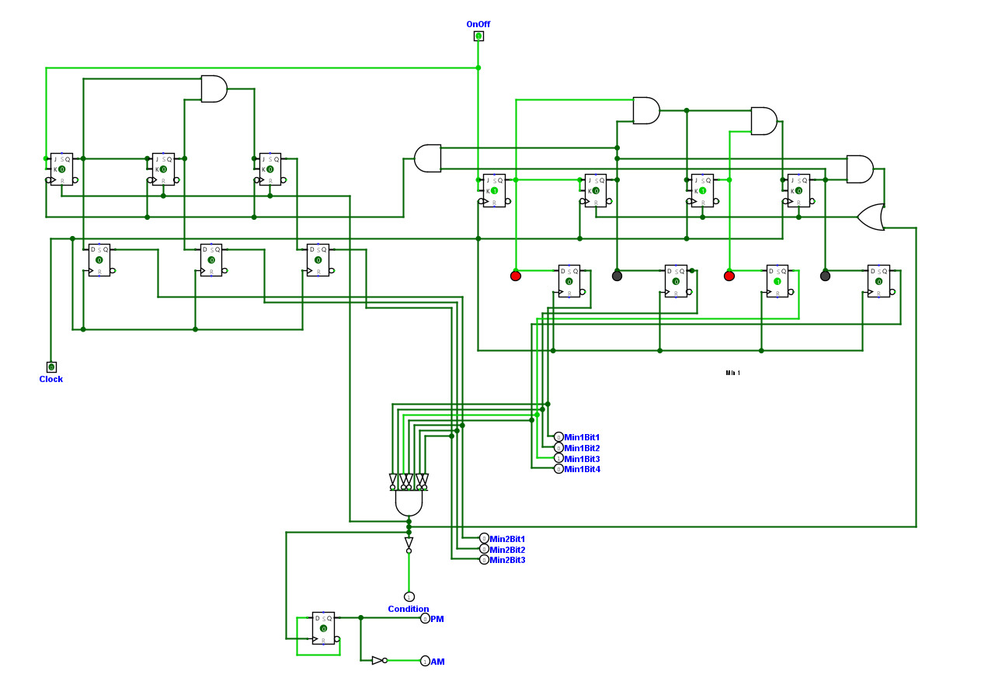

2.2.3. Hours part

To make the circuit look clean, I decided to use a sub-circuit for the main circuit. The main circuit. Firstly, the interconnection among each part of the main clock is the reset condition and will become the clock pulse of the higher unit. With functional buttons, I use logic gates “and” and “or”. When “set time” and “set alarm” are on, both the alarm and main clock will stop, but when “set time” is on, the user can only add Hours and plus Minutes to the main clock, and the alarm clock will be paused. The opposite things are applied to “set alarm”.

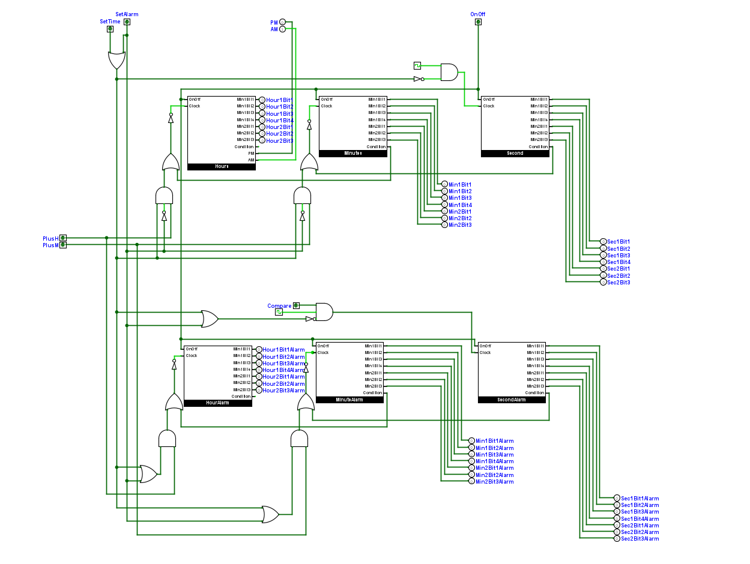

2.2.4. Main circuit

Compare circuit is used to compare the status alarm clock and main clock, if they have the same, the output will be 1 and opposite. The logic of this circuit simply is using XNOR gate, when input has the same status, the output will be 1.

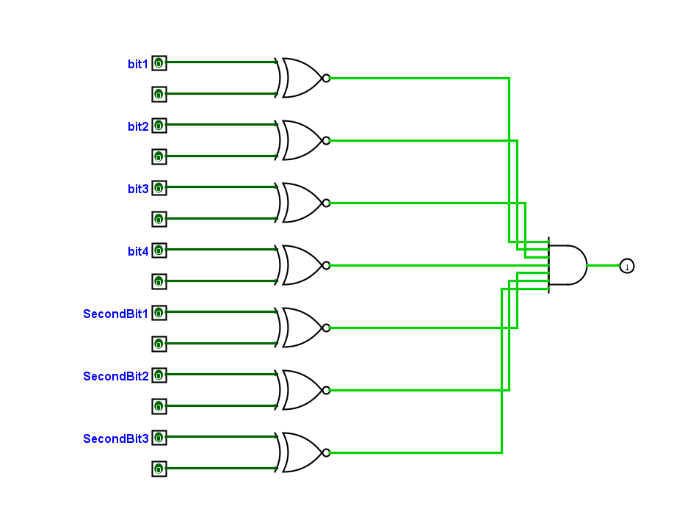

2.2.5. Compare circuit

The other circuit to make alarm function work is the switch display circuit, because the whole clock will have to display 2 clock on a screen, that means we have to change between 2 clocks.

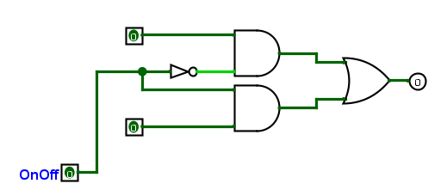

2.2.6. Switch display circuit

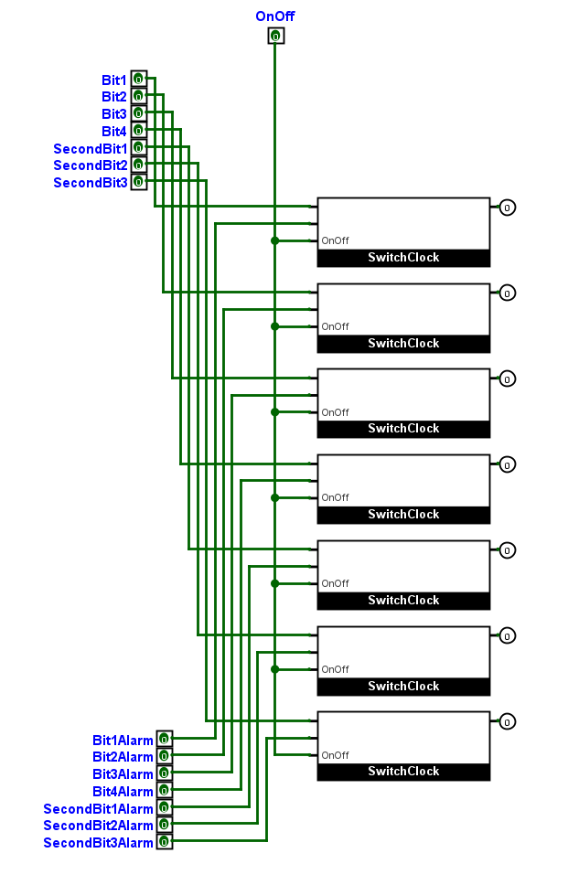

2.2.7. Total switch display circuit

After finishing a number of small sub-circuit, the clock display circuit will display the hex display of the clock. The logic of this circuit is when alarm and main clock has the same circuit, it will allow alarm clock’s clock pulse go to the alarm clock circuit, so that the alarm could run parallel with the main clock. Simultaneously, when the “set alarm” on, it will change to the alarm clock display and allow it to plus hours and minutes.

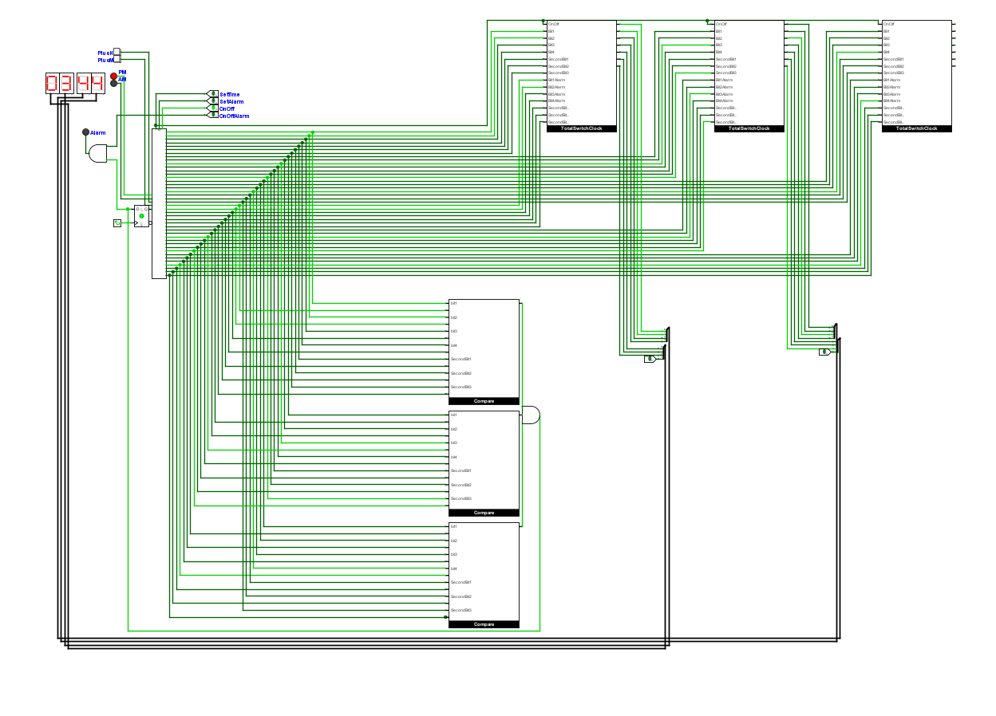

2.2.8. Main display circuit

III. Assumption

During this project, I built up the clock without any assumption. All the logic in this can be found in the previous lectures.

IV. Unsolved problems

No problems are found in this assignment. Simultaneously, with the using of 2 clock, I could make the extra time – which is when the alarm clock is set, the main clock continue to run without delayed by the time user setting the alarm.